EXPERIMENT NO 1:
Implement and demonstrate the FIND-S algorithm for finding the most specific hypothesis based on a given set of training data samples.
Aim:
To implement and demonstrate the FIND-S Algorithm for finding the most specific hypothesis that is consistent with the given set of positive training examples.

Procedure:
- Define the training dataset in the program.
- Initialize the hypothesis using the first positive training example.
- Compare the hypothesis with each positive example in the dataset.
- If an attribute value differs, replace it with '?' to generalize the hypothesis.
- Ignore all negative training examples.
- Continue until all training examples are processed.
- Display the final most specific hypothesis.

Program:
# FIND-S Algorithm
# Training Dataset
data = [
['Sunny', 'Warm', 'Normal', 'Strong', 'Warm', 'Same', 'Yes'],
['Sunny', 'Warm', 'High', 'Strong', 'Warm', 'Same', 'Yes'],
['Rainy', 'Cold', 'High', 'Strong', 'Warm', 'Change', 'No'],
['Sunny', 'Warm', 'High', 'Strong', 'Cool', 'Change', 'Yes']
]
# Number of attributes
num_attributes = len(data[0]) - 1
# Initialize hypothesis
hypothesis = None
# Find the first positive example
for row in data:
if row[-1] == "Yes":
hypothesis = row[:-1]
break
# Apply FIND-S Algorithm
for row in data:
if row[-1] == "Yes":
for i in range(num_attributes):
if hypothesis[i] != row[i]:
hypothesis[i] = '?'
# Display the results
print("Training Data:\n")
for row in data:
print(row)
print("\nMost Specific Hypothesis:")
print(hypothesis)

OUTPUT:
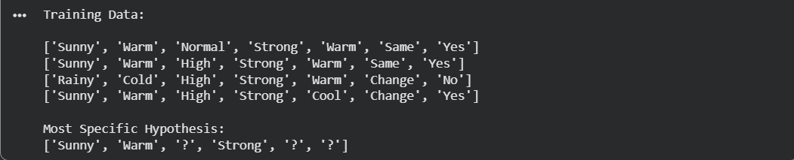

Result:
The FIND-S algorithm was successfully implemented and executed. The most specific hypothesis obtained from the given training data is:

